**07-02-2022 Functions**

**no argumnt no return type**

//1C prgrm to swap two variable using function

//input 1,2

//expected output=2,1

#include<stdio.h>

void swap();

int main()

{

swap();

}

void swap()

{

int a,b,c;

a=1;

b=2;

printf("Value before swap:%d %d",a,b);

c=b;

b=a;

a=c;

printf("using function no argumnt no return type Value after swap:%d %d",a,b);

return 0;

}

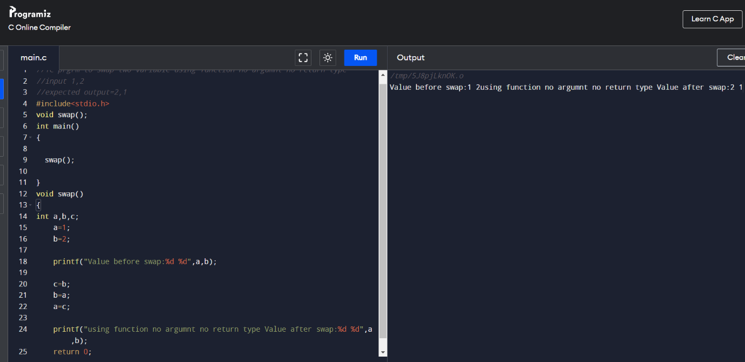

//101 To differentiate between int and float value

//prgm to print integer and float values of no

//using no argmnt ,no return type of function

//input=5.6

//output= int=5 , float=.6

#include<stdio.h>

void diff();

void main()

{

diff();

}

void diff()

{

float x;

int y;

float z;

printf("Enter the number: ");

scanf("%f",&x);

y= x;

z=x-y;

printf("Int is: %d, Float is: %f ",y,z);

}

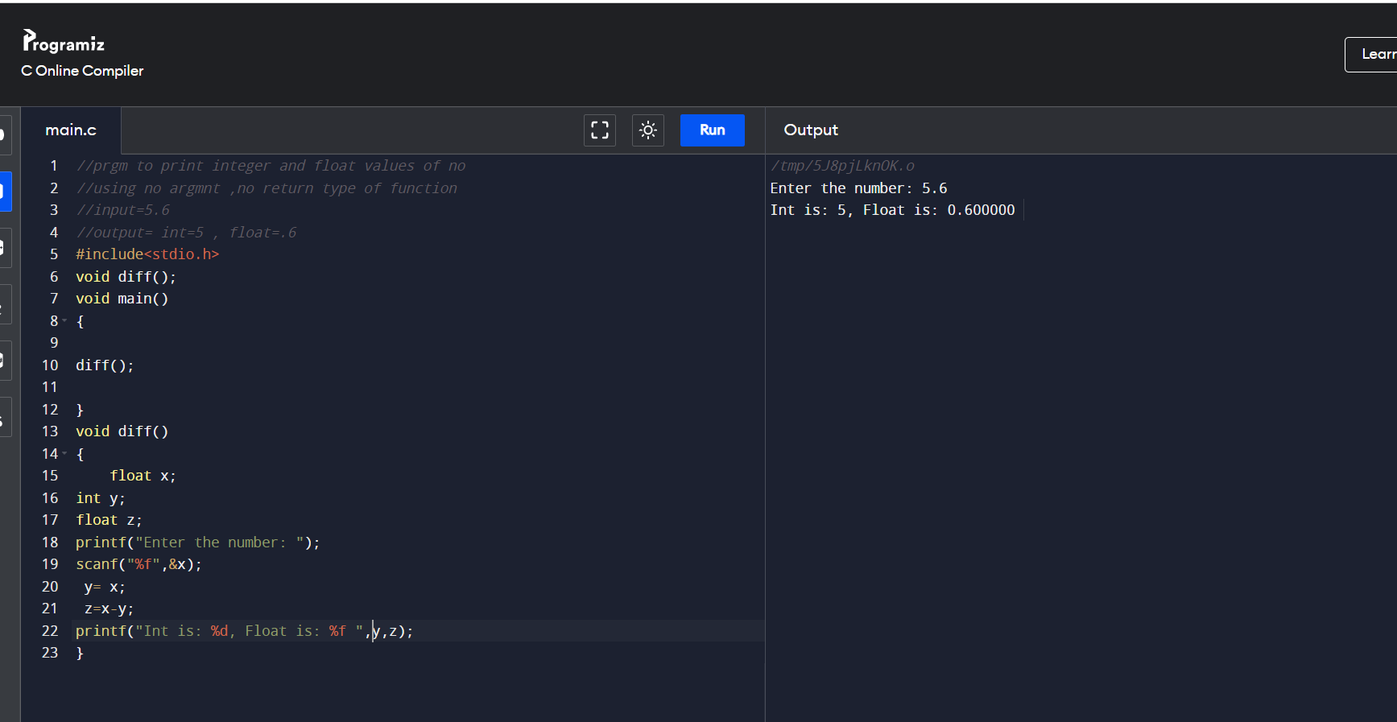

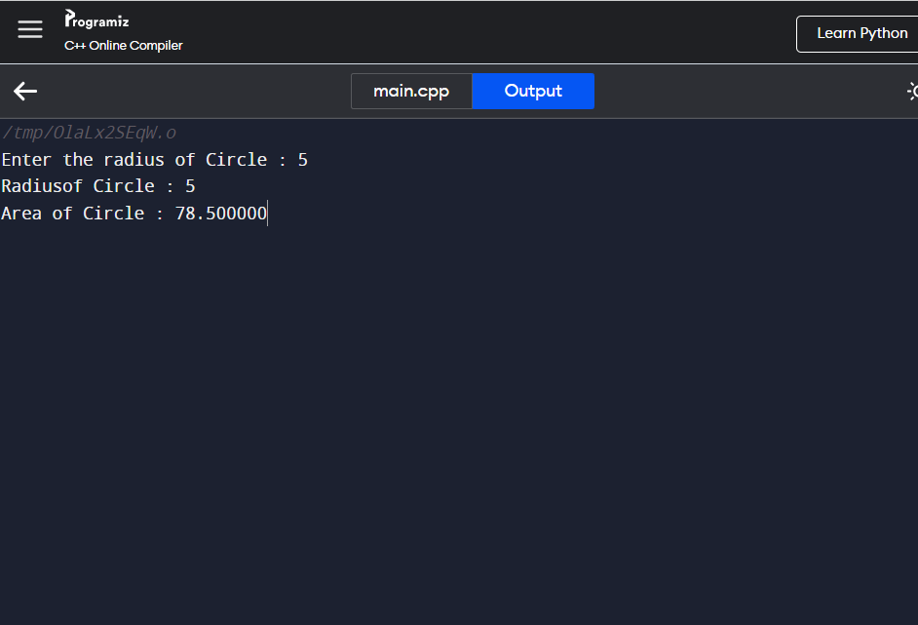

//104 Wap to find area of Rectangle

//prgm to print integer and float values of no

//using no argmnt ,no return type of function

//input=5 6

//output= 30

#include<iostream>

#include<cstdio>

void area();

int main()

{

area();

}

void area()

{

int width=5;

int height=10;

int area=width*height;

printf("Area of the rectangle=%d",area);

}

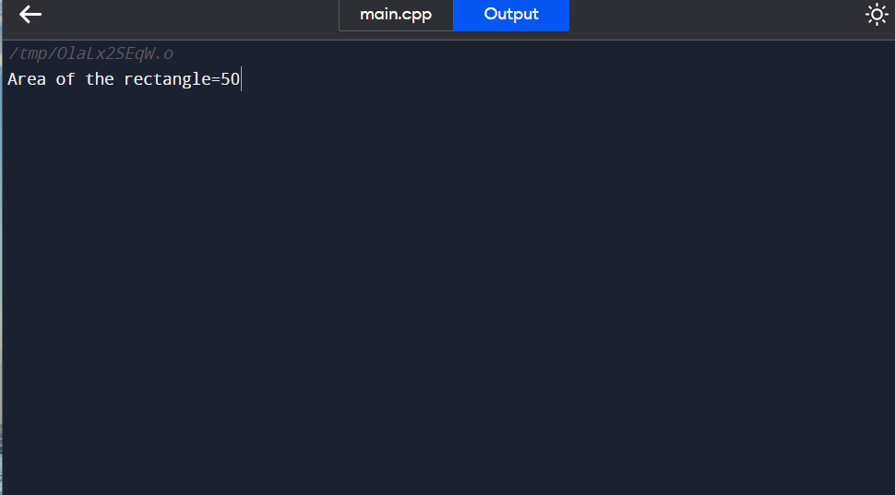

//105 Calculate simple interest

#include <stdio.h>

float value(void);

void main()

{

float f=value();

printf(" The total amount is %f:", f);

}

float value(void)

{

int year = 1, period = 5, amount = 5000, inrate = 0.12;

float sum;

sum = amount;

while (year <= period) {

sum = sum * (1 + inrate);

year = year + 1;

}

return sum;

}

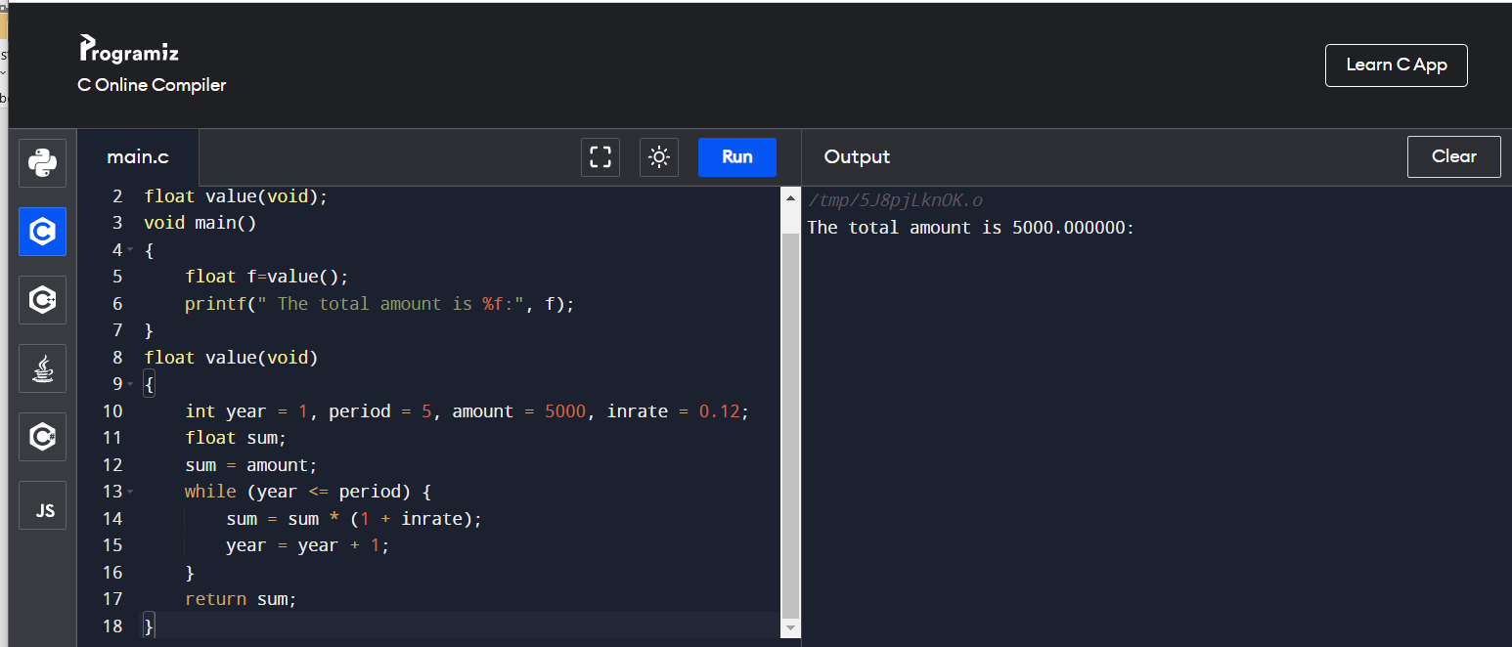

//106 Compound interest no return and no Argument

//no ARGUMENT AND no RETURN VALUE

//input=5000 ,3,2

//output= 8450,13450

#include<stdio.h>

#include<math.h>

void fun();

void main()

{

fun();

}

void fun()

{

float p,r,t,ci,amount;

printf("Enter Principle, Rate and Time: ");

scanf("%f%f%f",&p,&r,&t);

ci=p*pow((1+r/100),t);

printf("Bank Loans Compound Interest = %f\n",ci);

amount =ci + p;

printf("amount is %f",amount);

}

//107 Compound interest With return and no Argument

#include <stdio.h>

float compound(void);

void main()

{

float f=compound();

printf(" The total amount is %f:", f);

}

float compound(void)

{

float p,r,t,ci,amount;

printf("Enter Principle, Rate and Time: ");

scanf("%f%f%f",&p,&r,&t);

ci=p*pow((1+r/100),t);

printf("Bank Loans Compound Interest = %f\n",ci);

amount =ci + p;

return amount;

}

//108 compund interest With argument and no return value

//With argument and no return value

//input=5000 ,.03,2

//output=

#include<stdio.h>

#include<math.h>

void fun(float,float,float);

void main()

{

float p,r,t;

printf("\nEnter the values of princple,intrest to given and time : ");

scanf("%f %f %f",&p,&r,&t);

fun(p,r,t);

}

void fun(float x1,float x2,float x3)

{

float ci,amount;

ci=x1*pow((1+x2/100),x3);

printf("Bank Loans Compound Interest = %f\n",ci);

amount =ci + x1;

printf("\namount t is : %f",amount);

}

109

//WITH ARGUMENT AND WITH RETURN VALUE

//input=5000 ,.03,2

//output=

#include<stdio.h>

#include<math.h>

int fun(float,float,float);

void main()

{

float p,r,t,amount;

printf("\nEnter the values of princple,intrest to given and time : ");

scanf("%f %f %f",&p,&r,&t);

amount =fun(p,r,t);

printf("amount is %f",amount);

}

int fun(float x1,float x2,float x3)

{

float ci;

ci=x1*pow((1+x2/100),x3);

printf("Bank Loans Compound Interest = %f\n",ci);

return (ci + x1);

}

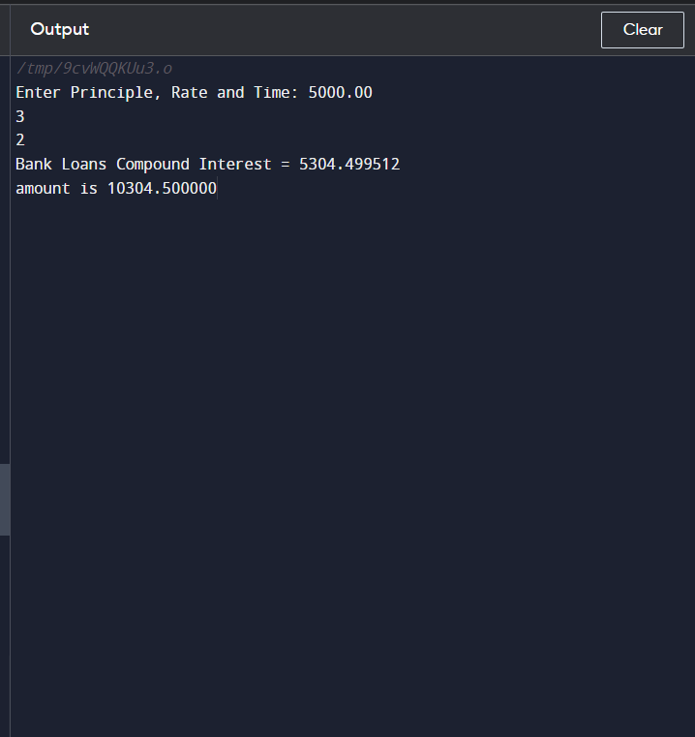

//110number is even or not no return function no argrumnt

#include <stdio.h>

//input= 2 4 6 10 15

//expected output =2 4 6 10

void fun();

int main()

{

fun();

}

void fun()

{

int i, j, a, n, number[30];

printf("Enter the value of N \n");

scanf("%d", &n);

printf("Enter the numbers \n");

for (i = 0; i < n; ++i)

scanf("%d", &number[i]);

for (i = 0; i < n; ++i)

{

if(number[i]%2==0)

printf("%d is even\n",number[i]);

}

}

//111 number is even or not no return function with argrumnt

//no return value ,With argument

//input=5000 ,.03,2

//output=

#include<stdio.h>

#include<math.h>

void fun(int);

void main()

{

int p;

printf("\nEnter the number: ");

scanf("%d",&p);

fun(p);

}

void fun(int num)

{

// true if num is perfectly divisible by 2

if(num % 2 == 0)

printf("%d is even.", num);

else

printf("%d is odd.", num);

}

//112number is even or not with return function no argrumnt

//with RETURN VALUE ,no ARGUMENT

//input=5

//output= 5 is odd

#include<stdio.h>

#include<math.h>

int fun();

void main()

{

int take;

take=fun();

if(take == 1)

printf("Entered number is even.");

else

printf("Entered number is odd");

}

int fun()

{

int num;

printf("Enter an integer: ");

scanf("%d", &num);

// true if num is perfectly divisible by 2

if(num % 2 == 0)

return 1;

else

return 0;

}

//113number is even or not with return function with argrumnt

// WITH RETURN VALUE, WITH ARGUMENT

//no return AND no arg VALUE

//input=5

//output= 5 is odd

#include<stdio.h>

#include<math.h>

int fun(int);

void main()

{

int p,take;

printf("\nEnter the number: ");

scanf("%d",&p);

take=fun(p);

if(take == 1)

printf("Entered number is even.");

else

printf("Entered number is odd");

}

int fun(num)

{

// true if num is perfectly divisible by 2

if(num % 2 == 0)

return 1;

else

return 0;

}

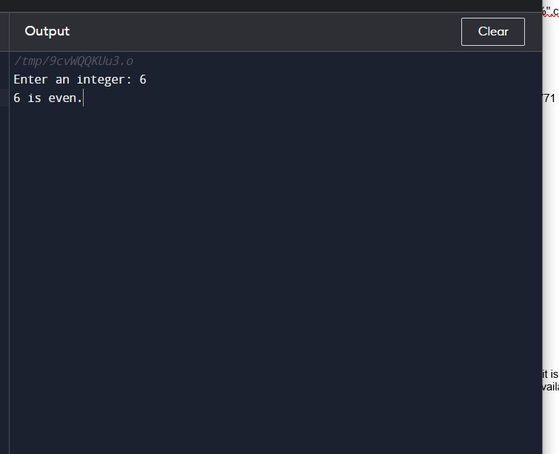

//114progrm to print odd number

#include <stdio.h>

//input= 1 3 5 8 6

//expected output =1 3 5 ,3

void fun();

int main()

{

fun();

}

void fun()

{

int i, j, a, n, number[30],count=0;

printf("Enter the value of N \n");

scanf("%d", &n);

printf("Enter the numbers \n");

for (i = 0; i < n; ++i)

scanf("%d", &number[i]);

for (i = 0; i < n; ++i)

{

if(number[i]%2==1)

{printf("%d is odd\n",number[i]);

count++;

}

}

printf("total odd no are:%d",count);

}

 130 Addition of each element of array

#include <stdio.h>

//input= 12 123 1234 12389

//expected output =2 3 4 5

void fun();

int main()

{

fun();

}

void fun()

{

int n,r,sum,arr[10],i,temp;

int count = 0;

// iterate at least once, then until n becomes 0

// remove last digit from n in each iteration

// increase count by 1 in each iteration

printf("Enter size of the array : ");

scanf("%d",&n);

printf("Enter elements in array : ");

for(i=0; i<n; i++)

{

scanf("%d",&arr[i]);

}

for(i=0; i<n; i++)

{

temp=arr[i];

while(temp!=0)

{

r = temp%10;

count++;

temp/= 10;

}

printf("Number of digits is %d\n", count);

count=0;

}

}

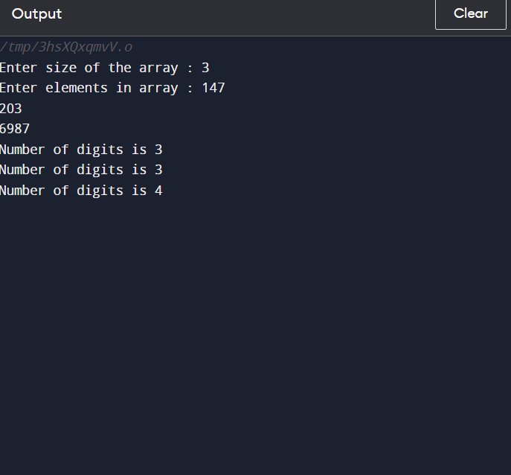

//132 Write a program to find prime numbers ina Array

#include <stdio.h>

//input= 1 3 5 9 10 12

//expected output =1 3 5 9

void fun();

int main()

{

fun();

}

void fun()

{

int n,arr[10],i,temp,k,flag=0;

int count = 0;

printf("Enter size of the array : ");

scanf("%d",&n);

printf("Enter elements in array : ");

for(i=0; i<n; i++)

{

printf("storing value at %d",i);

scanf("%d",&arr[i]);

}

for(i=0; i<n; i++)

{

temp=arr[i];

for(k=2;k<temp;k++)

{

if(temp%k == 0)

flag=1;

}

if(flag==0)

{

printf("%d is prime\n",arr[i]);

count++;

}

}

printf("Number of prime numbers in aarry is %d\n", count);

}

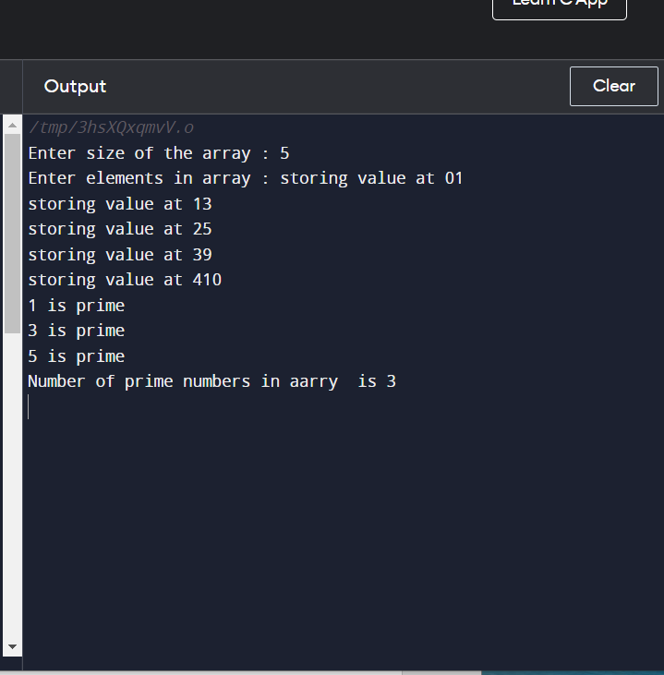

With Argument and Return Values

//136 Write a program to swap two values

//1C prgrm to swap two variable using function

//input 1,2

//expected output=2,1

//with argument and return values

#include<stdio.h>

void swap(int ,int);

int main()

{

int a,b;

a=1;

b=2;

printf("Value before swap:%d %d\n",a,b);

swap(a,b);

}

void swap(int a1,int b1)

{

int c;

c=b1;

b1=a1;

a1=c;

printf("using function with argumnt no return type Value after swap:%d %d",a1,b1);

}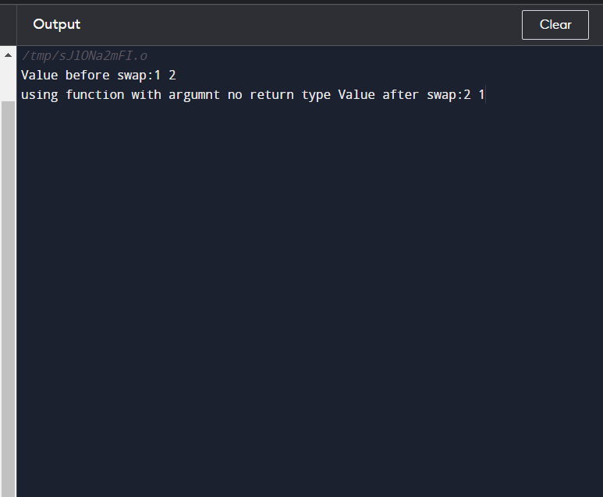

//137 Write a Program to diffrenciate between float and integer

//With argument and return value

//101 To differentiate between int and float value

//prgm to print integer and float values of no

//using no argmnt ,no return type of function

//input=5.6

//output= int=5 , float=.6

#include<stdio.h>

void diff(float );

void main()

{

float x;

printf("Enter the number: ");

scanf("%f",&x);

diff(x);

}

void diff(float x1)

{

int y;

float z;

y= x1;

z=x1-y;

printf("Int is: %d, Float is: %f ",y,z);

}x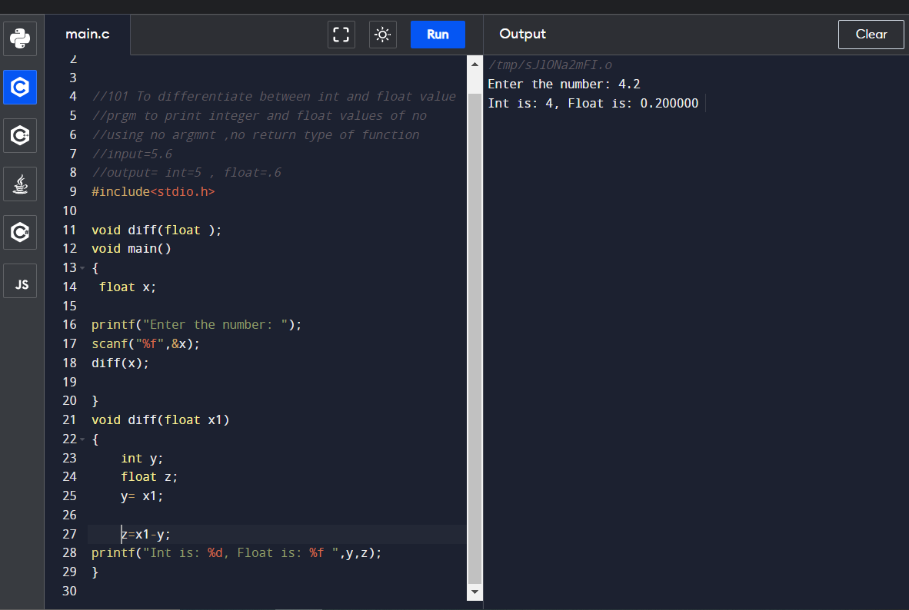

//138 Print area of cirlce

//With argument and no return value

//101 To differentiate between int and float value

//prgm to print integer and float values of no

//using no argmnt ,no return type of function

//input=5.2

//output= 3.14 * 5 *5 = 84.9056 ude<stdio.h>

#include<stdio.h>

void fun(float );

void main()

{

float radius;

printf("\nEnter the radius of Circle : ");

scanf("%f",&radius);

fun(radius);

}

void fun(float x1)

{

float area;

area = 3.14 * x1 * x1;

printf("\nArea of Circle : %f", area);

}

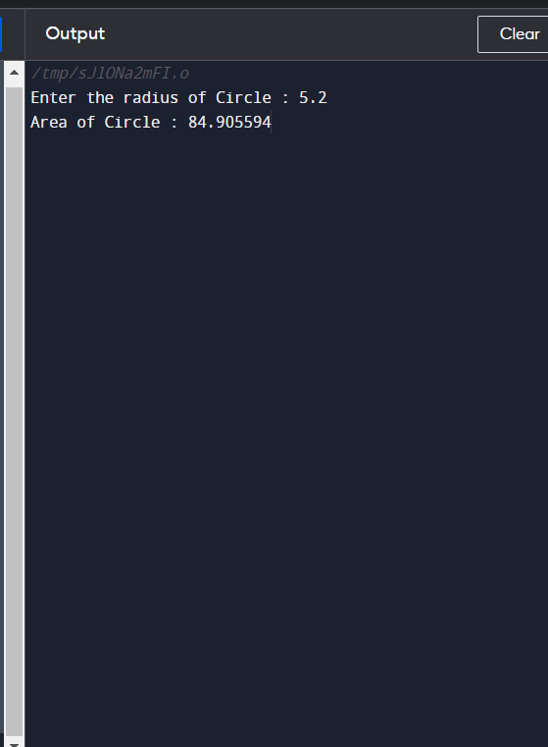

//137 to Differentiate between int and float with with argument and return value

//With argument and no return value

//101 To differentiate between int and float value

//prgm to print integer and float values of no

//using no argmnt ,no return type of function

//input=5.2

//output= 3.14 * 5 *5 = 84.9056 ude<stdio.h>

#include<stdio.h>

void fun(float );

void main()

{

float radius;

printf("\nEnter the radius of Circle : ");

scanf("%f",&radius);

fun(radius);

}

void fun(float x1)

{

float area;

area = 3.14 * x1 * x1;

printf("\nArea of Circle : %f", area);

}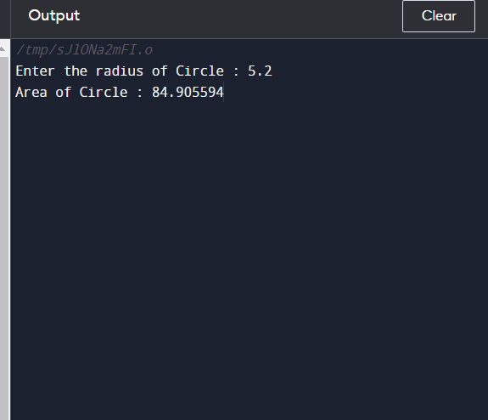

//140 Area of square

//With argument and no return value

//input=5

//output= 25

#include<stdio.h>

void fun(float );

void main()

{

float side;

printf("\nEnter the side of square : ");

scanf("%f",&side);

fun(side);

}

void fun(float x1)

{

float area;

area = x1 * x1;

printf("\nArea of square : %f", area);

}

}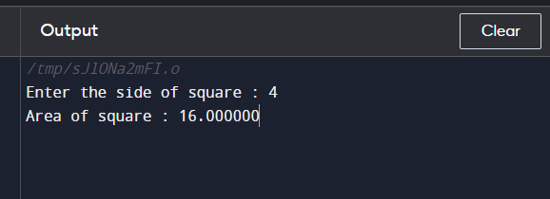

//140 Area of rectangle

//With argument and no return value

//input=5 ,4

//output= 20

#include<stdio.h>

void fun(float,float);

void main()

{

float a,b;

printf("\nEnter the values of rectangle : ");

scanf("%f %f",&a,&b);

fun(a,b);

}

void fun(float x1,float x2)

{

float area;

area = x1 * x2;

printf("\nArea of rectangle : %f", area);

}

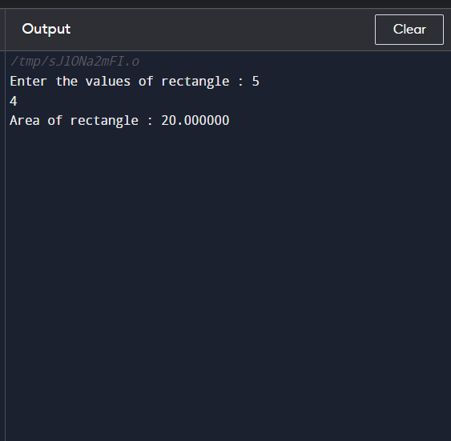

//141 Wap to calculate simple interest with function of no argument nd no return value

//no ARGUMENT AND no RETURN VALUE

//input=5000 ,.03,2

//output=

#include<stdio.h>

void fun();

void main()

{

fun();

}

void fun()

{

float si,p,r,t,amount;

printf("\nEnter the values of princple,intrest to given and t:");

scanf("%f %f %f",&p,&r,&t);

si = p * r * t;

printf("\nsimple interest is : %f",si);

amount =si + p;

printf("amount is %f",amount);

}

142 Calculate simple interest with argument and no return value

//With argument and no return value

//input=5000 ,.03,2

//output=

#include<stdio.h>

void fun(float,float,float);

void main()

{

float p,r,t;

printf("\nEnter the values of princple,intrest to given and time : ");

scanf("%f %f %f",&p,&r,&t);

fun(p,r,t);

}

void fun(float x1,float x2,float x3)

{

float si,amount;

si = x1 * x2 *x3;

amount =si + x1;

printf("\nsimple interest is : %f,amount is %f",si,amount);

}

//143

//WITH ARGUMENT AND WITH RETURN VALUE

//input=5000 ,.03,2

//output=

#include<stdio.h>

int fun(float,float,float);

void main()

{

float p,r,t,amount;

printf("\nEnter the values of princple,intrest to given and time : ");

scanf("%f %f %f",&p,&r,&t);

amount =fun(p,r,t);

printf("amount is %f",amount);

}

int fun(float x1,float x2,float x3)

{

float si,amount1;

si = x1 * x2 *x3;

printf("\nsimple interest is : %f",si);

amount1 =si + x1;

return (amount1);

}

//144 No ARGUMENT AND WITH RETURN VALUE

//no ARGUMENT AND RETURN VALUE

//input=5000 ,.03,2

//output=

#include<stdio.h>

int fun();

void main()

{

float amount;

amount=fun();

printf("amount is %f",amount);

}

int fun()

{

float si,p,r,t,amount1;

printf("\nEnter the values of princple,intrest to given and t:");

scanf("%f %f %f",&p,&r,&t);

si = p * r * t;

printf("\nsimple interest is : %f",si);

amount1 =si + p;

return amount1;

}

// 145 program to convert kilometer to meter

//no return AND no arg VALUE

//input=6000

//output= km=6, yes deleiverable

#include<stdio.h>

#include<math.h>

void fun();

void main()

{

fun();

}

void fun()

{

int a;

float b;

printf("enter the number");

scanf("%d",&a);

b = a/1000;

if(b>5)

printf("km=%.0f ,Home delivery is Available",b);

else

printf("km=%.0f,delievert not available",b);

}

146 //no return value ,With argument

//input=5000 ,.03,2

//output=

#include<stdio.h>

#include<math.h>

void fun(int);

void main()

{

int a;

float b;

printf("enter the number");

scanf("%d",&a);

b = a/1000;

fun(b);

}

void fun(int x1)

{

if(x1>5)

printf("km=%.0f ,Home delivery is Available",x1);

else

printf("km=%.0f,delievert not available",x1);

}

147

// WITH RETURN VALUE, WITH ARGUMENT

//no return AND no arg VALUE

//input=5

//output= 5 is odd

#include<stdio.h>

#include<math.h>

int fun(int);

void main()

{

int p,take;

float b;

printf("\nEnter the number: ");

scanf("%d",&p);

b = p/1000;

take=fun(p);

if(take == 1)

printf("km=%.0f ,Home delivery is Available",b);

else

printf("km=%.0f,delievert not available",b);

}

int fun(int x1)

{

// true if num is perfectly divisible by 2

if(x1>5)

return 1;

else

return 0;

}

148 //with RETURN VALUE ,no ARGUMENT

//input=5

//output= 5 is odd

#include<stdio.h>

#include<math.h>

int fun();

void main()

{

int take;

take=fun();

if(take == 1)

printf(",Home delivery is Available");

else

printf(",delievert not available");

}

int fun()

{

int a;

float b;

printf("enter the number");

scanf("%d",&a);

b = a/1000;

printf("km=%.0f",b);

if(b>5)

return 1;

else

return 0;

}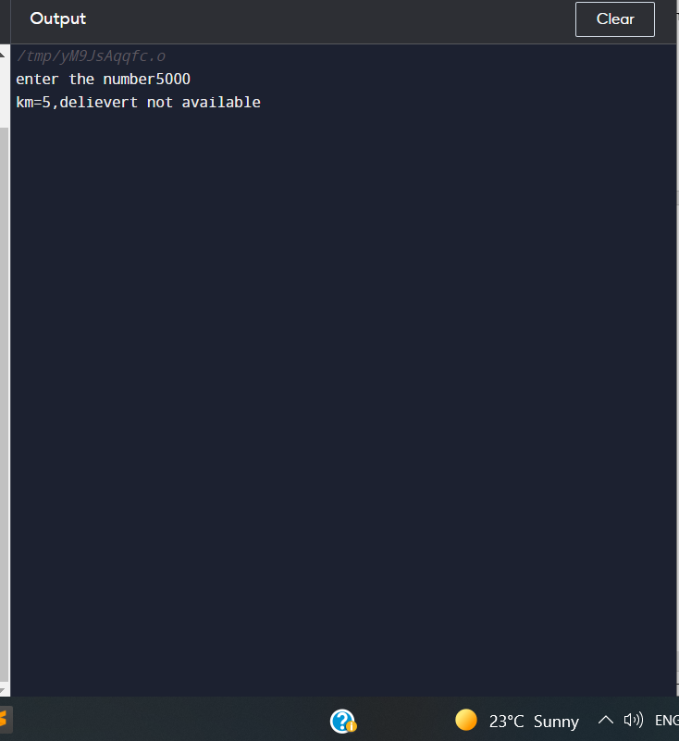

//149 To Calculate Factorial of number

//no return AND arg VALUE

//input=5

//output= factorial is 120

#include<stdio.h>

#include<math.h>

void fun(int);

void main()

{

int a;

printf("enter the number");

scanf("%d",&a);

fun(a);

}

void fun(int x1)

{

int fact=1,i;

for(i=1;i<=x1;i++)

{

fact=fact*i;

}

printf("factorial is =%d",fact);

}

151

// WITH RETURN VALUE, WITH ARGUMENT

//no return AND no arg VALUE

//input=5

//output= factorial is 120

#include<stdio.h>

#include<math.h>

int fun(int);

void main()

{

int p,take;

printf("\nEnter the number: ");

scanf("%d",&p);

take=fun(p);

printf("factorial is =%d",take);

}

int fun(int x1)

{

int i,fact=1;

for(i=1;i<=x1;i++)

{

fact=fact*i;

}

return fact;

}

152 factorial //with RETURN VALUE ,no ARGUMENT

//input=5

//output = factorial is 120

#include<stdio.h>

#include<math.h>

int fun();

void main()

{

int take;

take=fun();

printf("factorial is =%d",take);

}

int fun()

{

int a;

\

printf("enter the number");

scanf("%d",&a);

int fact=1,i;

for(i=1;i<=a;i++)

{

fact=fact*i;

}

return fact;

}

//153 Reverse of number

// Reverse number

//no return AND no arg VALUE

//input=123

//output= 321

#include<stdio.h>

#include<math.h>

void fun();

void main()

{

fun();

}

void fun()

{

int remainder,res=0,i;

int number,t;

printf("enter the number");

scanf("%d",&number);

t=number;

for(i=0;number!='\0';i++)

{

remainder =number%10;

res=res*10+remainder;

number=number/10;

}

printf("Reverse of number:%d",res);

}

154 // Reverse number

//no return AND with arg VALUE

//input=123

//output= 321

#include<stdio.h>

#include<math.h>

void fun(int);

void main()

{

int a;

printf("enter the number");

scanf("%d",&a);

fun(a);

}

void fun(int x1)

{

int sum=0,rem;

while(x1>0)

{

rem=x1 % 10;

sum=sum*10 + rem;

x1=x1/10;

}

printf("reverse is %d",sum);

sum=0;

}

155 // WITH RETURN VALUE, WITH ARGUMENT

//no return AND no arg VALUE

//input=5

//output= 5 is odd

#include<stdio.h>

#include<math.h>

int fun(int);

void main()

{

int p,take;

printf("\nEnter the number: ");

scanf("%d",&p);

take=fun(p);

printf("Reverse value is %d",take);

}

int fun(int x1)

{

int rem,sum=0;

while(x1>0)

{

rem=x1% 10;

sum=sum*10 + rem;

x1=x1/10;

}

return sum;

}

156 // WITH RETURN VALUE, no ARGUMENT

//input=123

//output= 321

#include<stdio.h>

#include<math.h>

int fun();

void main()

{

int take;

take=fun();

printf("Reverse of number is %d",take);

}

int fun()

{

int sum=0,rem,p;

printf("\nEnter the number: ");

scanf("%d",&p);

// true if num is perfectly divisible by 2

while(p>0)

{

rem=p % 10;

sum=sum*10 + rem;

p=p/10;

}

return sum;

}

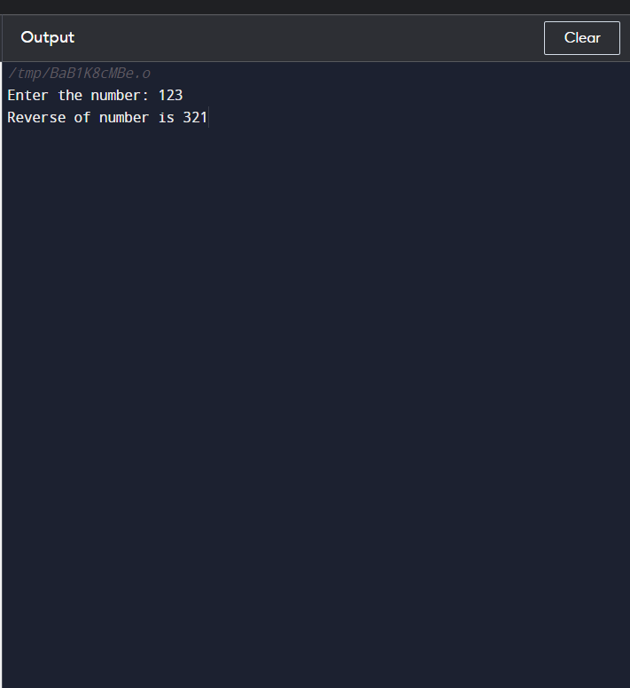

//157 // count digits of number

//no return AND no arg VALUE

//input=123

//output= count is 3

#include<stdio.h>

#include<math.h>

void fun();

void main()

{

fun();

}

void fun()

{

int number,count;

printf("enter the number");

scanf("%d",&number);

while(number>0)

{

count++;

number=number/10;

}

printf("count of digit in given number:%d",count);

}158 // count digits of number

//no return AND with arg VALUE

//input=123

//output= count is 3

#include<stdio.h>

#include<math.h>

void fun(int);

void main()

{

int a;

printf("enter the number");

scanf("%d",&a);

fun(a);

}

void fun(int x1)

{

int count=0;

while(x1>0)

{

count++;

x1=x1/10;

}

printf("count of digit in given number:%d",count);

}

159 // WITH RETURN VALUE, no ARGUMENT

//input=123

//output= count is 3

#include<stdio.h>

#include<math.h>

int fun();

void main()

{

int take;

take=fun();

printf("count of number is %d",take);

}

int fun()

{

int number,count=0;

printf("enter the number");

scanf("%d",&number);

while(number>0)

{

count++;

number=number/10;

}

return count;

}

// WITH RETURN VALUE, WITH ARGUMENT

//no return AND no arg VALUE

//input=123

//output= count is 3

#include<stdio.h>

#include<math.h>

int fun(int);

void main()

{

int p,take;

printf("\nEnter the number: ");

scanf("%d",&p);

take=fun(p);

printf("count value is %d",take);

}

int fun(int x1)

{

int number=x1,count=0;

while(number>0)

{

count++;

number=number/10;

}

return count;

}

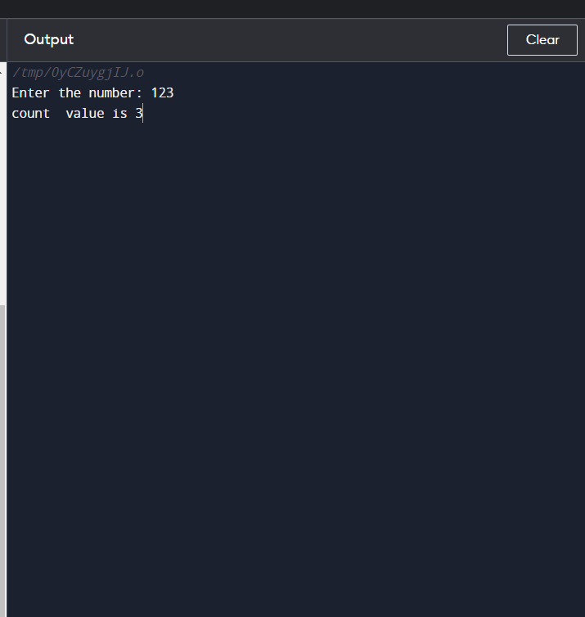

//160 // sum of digits of number

//no return AND no arg VALUE

//input=123

//output= count is 6

#include<stdio.h>

#include<math.h>

void fun();

void main()

{

fun();

}

void fun()

{

int number,sum=0,rem;

printf("enter the number");

scanf("%d",&number);

while(number>0)

{

rem=number%10;

sum=sum+rem;

number=number/10;

}

printf("sum of digit in given number:%d",sum);

}

161 // sum of digits of number

//no return AND with arg VALUE

//input=123

//output= sum is 6

#include<stdio.h>

#include<math.h>

void fun(int);

void main()

{

int a;

printf("enter the number");

scanf("%d",&a);

fun(a);

}

void fun(int x1)

{

int number=x1,sum=0,rem;

while(number>0)

{

rem=number%10;

sum=sum+rem;

number=number/10;

}

printf("sum of digit in given number:%d",sum);

}

162 // WITH RETURN VALUE, no ARGUMENT

//input=123

//output= sum is 6

#include<stdio.h>

#include<math.h>

int fun();

void main()

{

int take;

take=fun();

printf("sum of number is %d",take);

}

int fun()

{

int number,sum=0,rem;

printf("enter the number");

scanf("%d",&number);

while(number>0)

{

rem=number%10;

sum=sum+rem;

number=number/10;

}

return sum;

}

// WITH RETURN VALUE, WITH ARGUMENT

//no return AND no arg VALUE

//input=123

//output= sum is 6

#include<stdio.h>

#include<math.h>

int fun(int);

void main()

{

int p,take;

printf("\nEnter the number: ");

scanf("%d",&p);

take=fun(p);

printf("sum value is %d",take);

}

int fun(int x1)

{

int number=x1,sum=0,rem;

while(number>0)

{

rem=number%10;

sum=sum+rem;

number=number/10;

}

return sum;

}

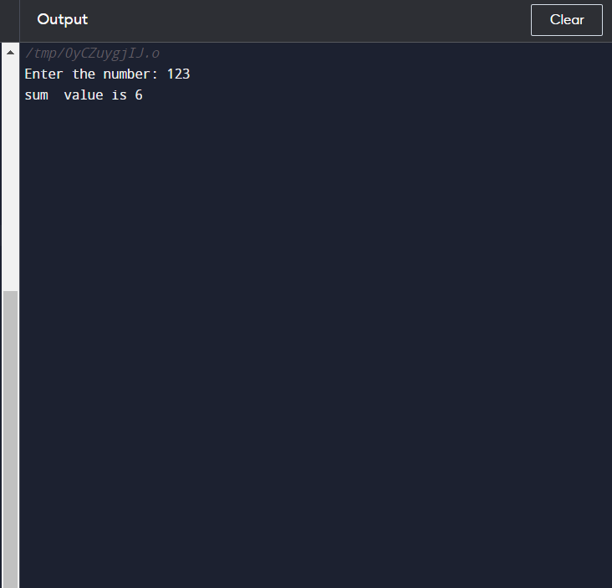

164 Pallindrome of a numbr

//no return AND no arg VALUE

// check number pallindrome or not

//input=121

//output= number is pallindrome

#include<stdio.h>

#include<math.h>

void fun();

void main()

{

fun();

}

void fun()

{

int i,n,r,s=0,temp;

printf("\n Enter The Number:");

scanf("%d",&n);

temp=n;

//LOOP TO FIND REVERSE OF A NUMBER

while(n>0)

{

r=n%10;

s=s*10+r;

n=n/10;

}

/* CHECKING IF THE NUMBER ENTERED AND THE REVERSE NUMBER IS EQUAL OR NOT */

if(s==temp)

{

printf("\n %d is a Palindrome Number",temp);

}

else

{

printf("\n %d is not a Palindrome Number",temp);

}

s=0;

}

// s of number

//no return AND with arg VALUE

// check number pallindrome or not

//input=121

//output= number is pallindrome

#include<stdio.h>

#include<math.h>

void fun(int);

void main()

{

int a;

printf("enter the number");

scanf("%d",&a);

fun(a);

}

void fun(int x1)

{

int n=x1;

int i,r,s=0,temp;

temp=n;

//LOOP TO FIND REVERSE OF A NUMBER

while(n>0)

{

r=n%10;

s=s*10+r;

n=n/10;

}

/* CHECKING IF THE NUMBER ENTERED AND THE REVERSE NUMBER IS EQUAL OR NOT */

if(s==temp)

{

printf("\n %d is a Palindrome Number",temp);

}

else

{

printf("\n %d is not a Palindrome Number",temp);

}

s=0;

}

// WITH RETURN VALUE, no ARGUMENT

// check number pallindrome or not

//input=121

//output= number is pallindrome

#include<stdio.h>

#include<math.h>

int fun();

void main()

{

int take;

take=fun();

if(take)

printf(" %d is pallindrome ",take);

else

printf(" %d is not pallindrome ",take);

}

int fun()

{

int n,r,s=0,temp;

printf("\n Enter The Number:");

scanf("%d",&n);

temp=n;

while(n>0)

{

r=n%10;

s=s*10+r;

n=n/10;

}

/* CHECKING IF THE NUMBER ENTERED AND THE REVERSE NUMBER IS EQUAL OR NOT */

if(s==temp)

{

return 1;

}

else

{

return 0;

}

s=0;

}

// WITH RETURN VALUE, WITH ARGUMENT

// check number pallindrome or not

//input=121

//output= number is pallindrome

#include<stdio.h>

#include<math.h>

int fun(int);

void main()

{

int p,take;

printf("\nEnter the number: ");

scanf("%d",&p);

take=fun(p);

if(p==take)

printf(" %d is pallindrome ",take);

else

printf(" %d is not pallindrome ",take);

}

int fun(int x1)

{

int n=x1,s=0,r;

int temp=n;

while(n>0)

{

r=n%10;

s=s*10+r;

n=n/10;

}

/* CHECKING IF THE NUMBER ENTERED AND THE REVERSE NUMBER IS EQUAL OR NOT */

if(s==temp)

{

return s;

}

else

{

return s;

}

s=0;

}

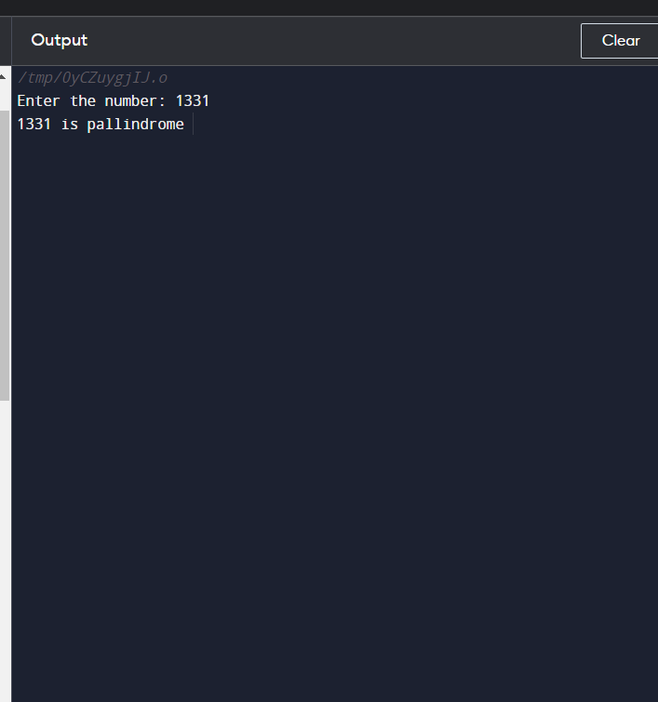

//168 //no return AND no arg VALUE

// check number Armstrong or not

//input=370

//output= number is Armstrong

#include<stdio.h>

#include<math.h>

void fun();

void main()

{

fun();

}

void fun()

{

int i,n,r,s=0,temp;

printf("\n Enter The Number:");

scanf("%d",&n);

temp=n;

//LOOP TO FIND REVERSE OF A NUMBER

while(n>0)

{

r=n%10;

s=r*r*r+s;

n=n/10;

}

/* CHECKING IF THE NUMBER ENTERED AND THE REVERSE NUMBER IS EQUAL OR NOT */

if(s==temp)

{

printf("\n %d is a Armstrong Number",temp);

}

else

{

printf("\n %d is not a Armstrong Number",temp);

}

s=0;

}

// s of number

//169 no return AND with arg VALUE

// check number Armstrong or not

//input=370

//output= number is Armstrong

#include<stdio.h>

#include<math.h>

void fun(int);

void main()

{

int a;

printf("enter the number");

scanf("%d",&a);

fun(a);

}

void fun(int x1)

{

int n=x1;

int i,r,s=0,temp;

temp=n;

//LOOP TO FIND REVERSE OF A NUMBER

while(n>0)

{

r=n%10;

s=r*r*r+s;

n=n/10;

}

/* CHECKING IF THE NUMBER ENTERED AND THE REVERSE NUMBER IS EQUAL OR NOT */

if(s==temp)

{

printf("\n %d is a Armstrong Number",temp);

}

else

{

printf("\n %d is not a Armstrong Number",temp);

}

s=0;

}

// WITH RETURN VALUE, no ARGUMENT

// 170 check number Armstrong or not

//input=370

//output= number is Armstrong

#include<stdio.h>

#include<math.h>

int fun();

void main()

{

int take;

take=fun();

if(take)

printf(" %d is Armstrong ",take);

else

printf(" %d is not Armstrong ",take);

}

int fun()

{

int n,r,s=0,temp;

printf("\n Enter The Number:");

scanf("%d",&n);

temp=n;

while(n>0)

{

r=n%10;

s=r*r*r+s;

n=n/10;

}

/* CHECKING IF THE NUMBER ENTERED AND THE REVERSE NUMBER IS EQUAL OR NOT */

if(s==temp)

{

return 1;

}

else

{

return 0;

}

s=0;

}

// WITH RETURN VALUE, WITH ARGUMENT

// 171 check number Armstrong or not

//input=370

//output= number is Armstrong

#include<stdio.h>

#include<math.h>

int fun(int);

void main()

{

int p,take;

printf("\nEnter the number: ");

scanf("%d",&p);

take=fun(p);

if(p==take)

printf(" %d is Armstrong ",take);

else

printf(" %d is not Armstrong ",take);

}

int fun(int x1)

{

int n=x1,s=0,r;

int temp=n;

while(n>0)

{

r=n%10;

s=r*r*r+s;

n=n/10;

}

/* CHECKING IF THE NUMBER ENTERED AND THE REVERSE NUMBER IS EQUAL OR NOT */

if(s==temp)

{

return s;

}

else

{

return s;

}

s=0;

}

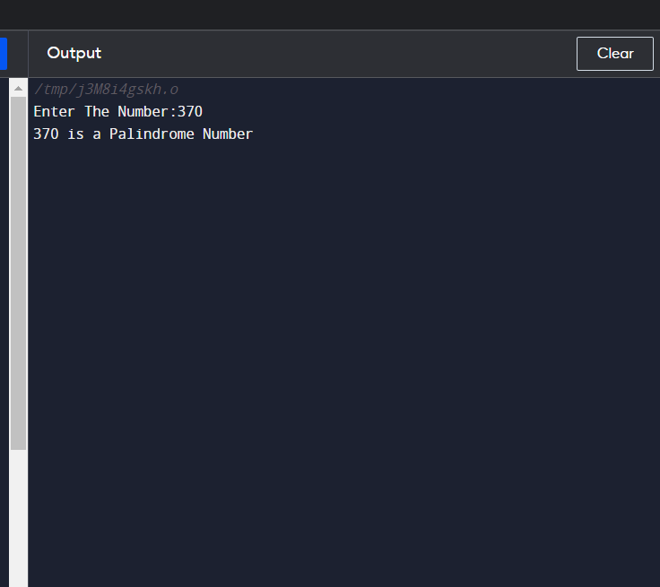

//

//no return AND no arg VALUE

// 172 Print calculated factorial number in range givn by user

//input=1 5

//output= factorial of number 1 is 1,

//factorial of number 2 is 2...

//factorial of number 3 is 6

#include<stdio.h>

#include<math.h>

void fun();

void main()

{

fun();

}

void fun()

{

int a,b,i,j,temp=0,fact;

printf("enter the numbers");

scanf("%d%d",&a,&b);

for(j=a;j<=b;j++)

{

temp=j;

fact=1;

for(i=1;i<=temp;i++)

{

fact=fact*i;

}

printf("factorial of %d is =%d\n ",j,fact);

}

}

// s of number

//173 no return AND with arg VALUE

// Print calculated factorial number in range givn by user

//input=1 5

//output= factorial of number 1 is 1,

//factorial of number 2 is 2...

//factorial of number 3 is 6

#include<stdio.h>

#include<math.h>

void fun(int,int);

void main()

{

int a,b;

printf("enter the numbers");

scanf("%d%d",&a,&b);

fun(a,b);

}

void fun(int x1,int x2)

{

int a=x1,b=x2,i,j,temp=0,fact;

for(j=a;j<=b;j++)

{

temp=j;

fact=1;

for(i=1;i<=temp;i++)

{

fact=fact*i;

}

printf("factorial of %d is =%d\n ",j,fact);

}

}

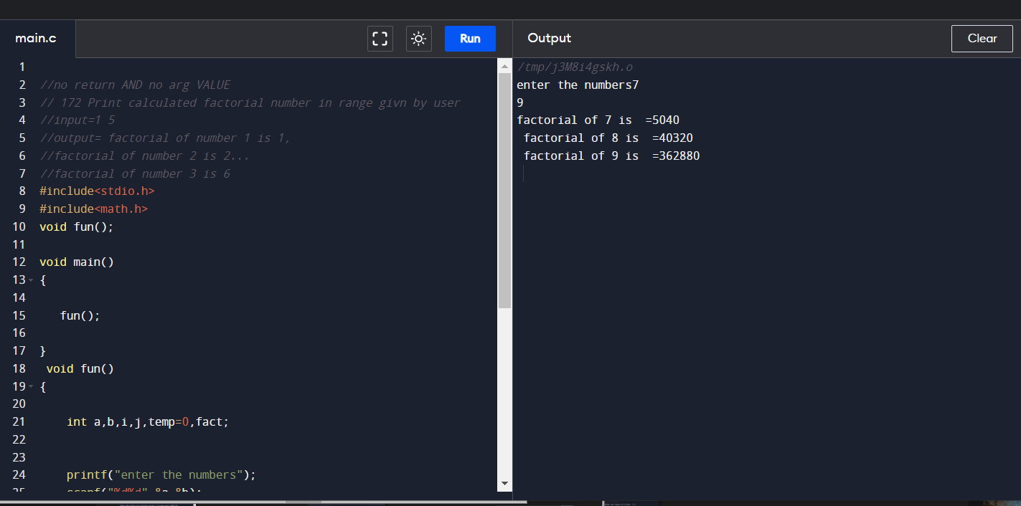

// //no return AND no arg VALUE

// 174 Print calculated pallindrome number in range givn by user

//input=1 10

//output= #include<stdio.h>

#include<math.h>

void fun();

void main()

{

fun();

}

void fun()

{

int a,b,i,j,temp=0,fact,n,r,s;

printf("enter the numbers");

scanf("%d%d",&a,&b);

for(j=a;j<=b;j++)

{

temp=j;

n=j;

//LOOP TO FIND REVERSE OF A NUMBER

while(n>0)

{

r=n%10;

s=s*10+r;

n=n/10;

}

/* CHECKING IF THE NUMBER ENTERED AND THE REVERSE NUMBER IS EQUAL OR NOT */

if(s==temp)

{

printf("\n %d is a Palindrome Number",temp);

}

else

{

printf("\n %d is not a Palindrome Number",temp);

}

s=0;

}

}

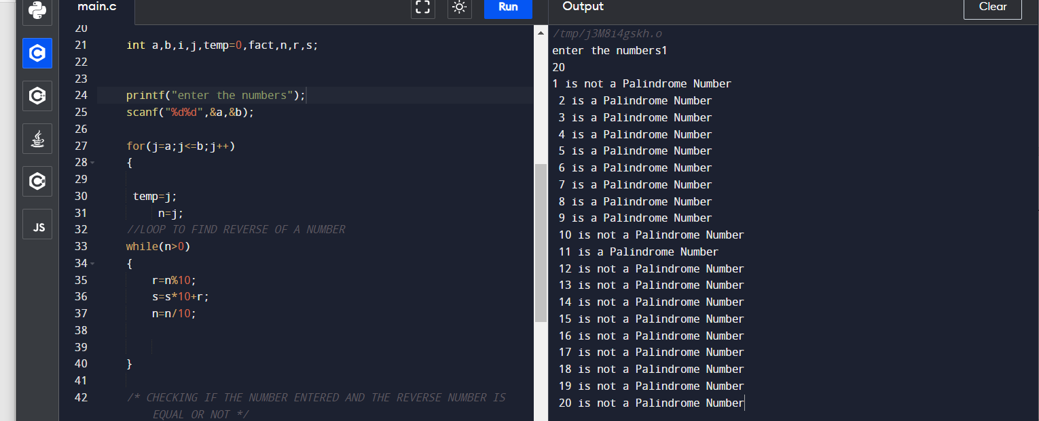

//no return AND no arg VALUE

// 176 Print calculated pallindrome number in range givn by user

//input=3 1 to 10

//output= number is Armstrong

#include<stdio.h>

#include<math.h>

void fun();

void main()

{

fun();

}

void fun()

{

int a,b,i,j,temp=0,fact,n,r,s;

printf("enter the numbers");

scanf("%d%d",&a,&b);

for(j=a;j<=b;j++)

{

temp=j;

n=j;

//LOOP TO FIND REVERSE OF A NUMBER

while(n>0)

{

r=n%10;

s=r*r*r+s;

n=n/10;

}

/* CHECKING IF THE NUMBER ENTERED AND THE REVERSE NUMBER IS EQUAL OR NOT */

if(s==temp)

{

printf("\n %d is a Armstrong Number",temp);

}

else

{

printf("\n %d is not a Armstrong Number",temp);

}

s=0;

}

}

// s of number

//175 no return AND with arg VALUE

//no return AND no arg VALUE

// 177 Print calculated pallindrome number in range givn by user

//input=1 10

//output=

#include<stdio.h>

#include<math.h>

void fun(int,int);

void main()

{

int a,b;

printf("enter the numbers");

scanf("%d%d",&a,&b);

fun(a,b);

}

void fun(int x1,int x2)

{

int a=x1,b=x2,i,j,temp=0,fact;

int n,r,s;

for(j=a;j<=b;j++)

{

temp=j;

n=j;

//LOOP TO FIND REVERSE OF A NUMBER

while(n>0)

{

r=n%10;

s=r*r*r+s;

n=n/10;

}

/* CHECKING IF THE NUMBER ENTERED AND THE REVERSE NUMBER IS EQUAL OR NOT */

if(s==temp)

{

printf("\n %d is a Armstrong Number",temp);

}

else

{

printf("\n %d is not a Armstrong",temp);

}

s=0;

}

}

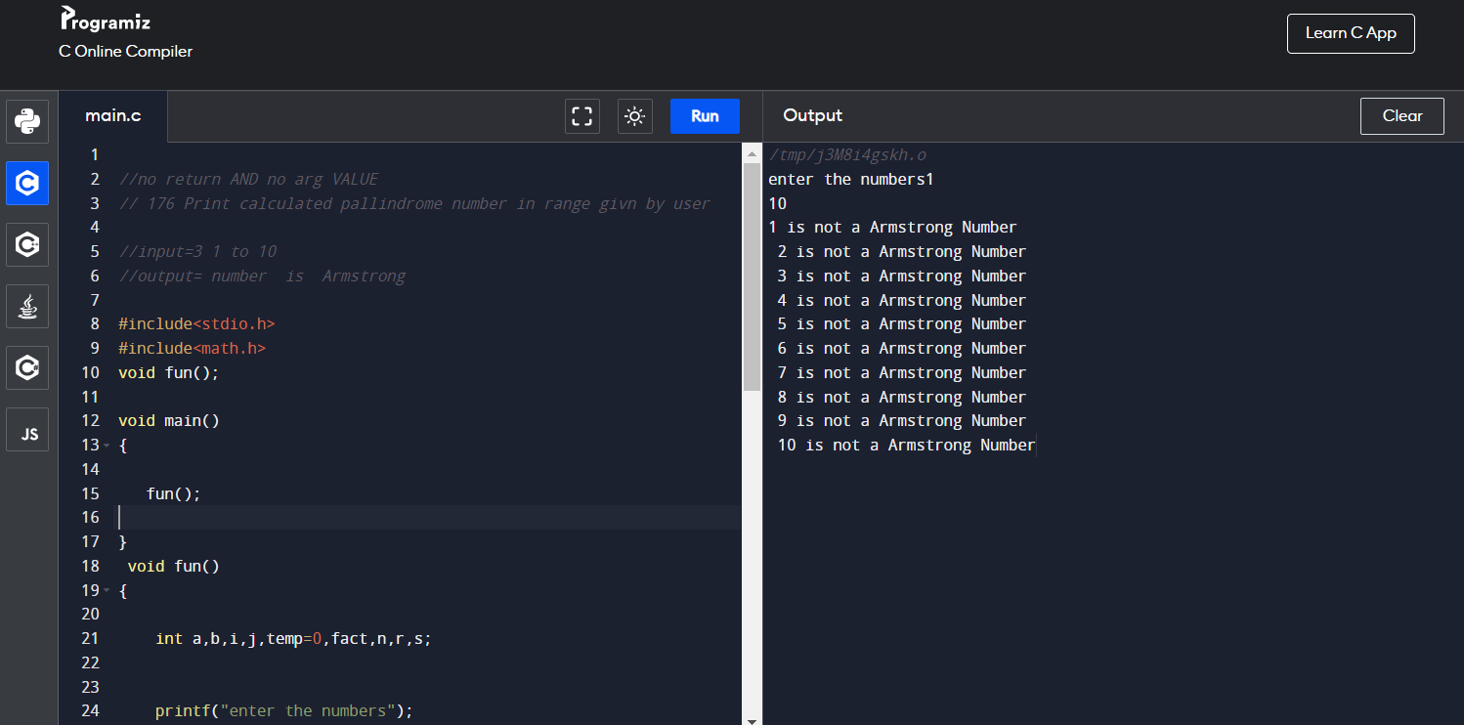

//no return AND no arg VALUE

// 178 Print calculated prime number in range givn by user

//input=3 1 to 10

//output= 1 number is prime

#include<stdio.h>

#include<math.h>

void fun();

void main()

{

fun();

}

void fun()

{

int a,b,i,j,temp=0,n,r,s;

printf("enter the numbers");

scanf("%d%d",&a,&b);

for(j=a;j<=b;j++)

{

temp=j;

int num=temp;

//loop counter

//it will be 1 when number is not prime

int flag=0;

//loop to check number is prime or not

//we will check, if number is divisible

//by any number from 2 to num/2, then it

//will not be prime

for(i=2; i<num/2; i++)

{

if(num%i ==0)

{

flag =1;

break;

}

}

//flag is 1, if number is not prime

if(flag==0)

printf("%d is prime",temp);

}

/* CHECKING IF THE NUMBER ENTERED AND THE REVERSE NUMBER IS EQUAL OR NOT */

}

// s of number

//175 no return AND with arg VALUE

//no return AND no arg VALUE

// 178 Print calculated pallindrome number in range givn by user

//input=1 10

//output=

#include<stdio.h>

#include<math.h>

void fun(int,int);

void main()

{

int a,b;

printf("enter the numbers");

scanf("%d%d",&a,&b);

fun(a,b);

}

void fun(int x1,int x2)

{

int a=x1,b=x2,i,j,temp=0,fact;

int n,r,s;

for(j=a;j<=b;j++)

{

temp=j;

int num=temp;

//loop counter

//it will be 1 when number is not prime

int flag=0;

//loop to check number is prime or not

//we will check, if number is divisible

//by any number from 2 to num/2, then it

//will not be prime

for(i=2; i<num/2; i++)

{

if(num%i ==0)

{

flag =1;

break;

}

}

//flag is 1, if number is not prime

if(flag==0)

printf("%d is prime",temp);

}

}

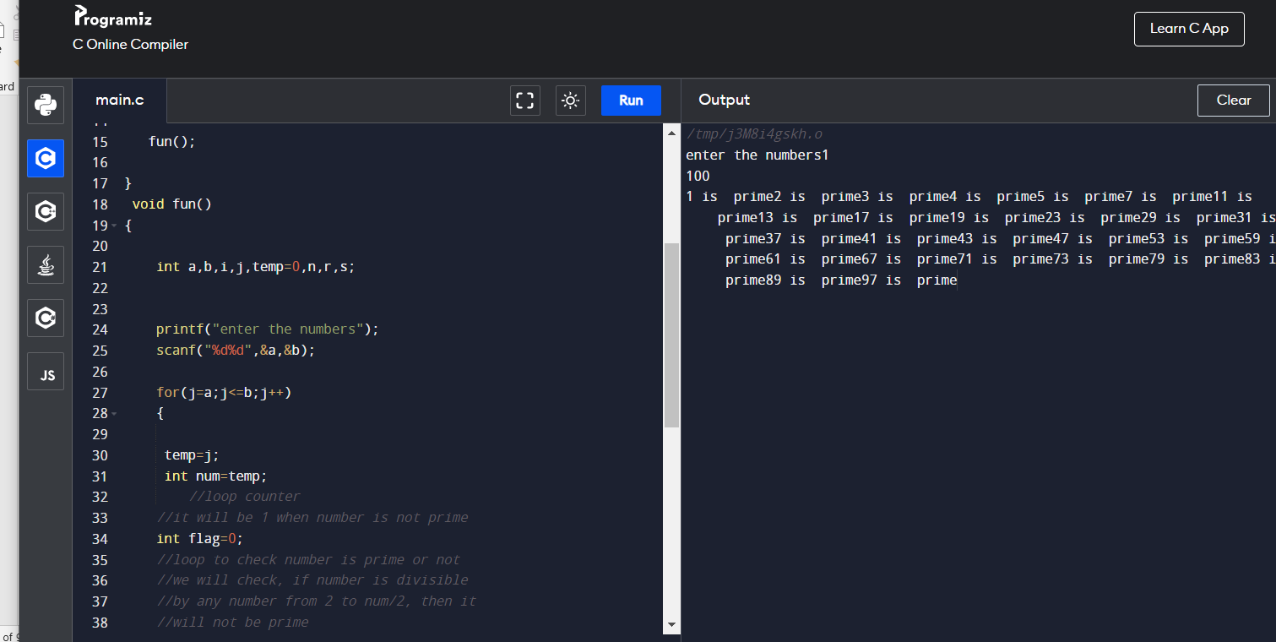

P23 Odd number in range

//no return AND no arg VALUE

// 179 Print calculated even number in range givn by user

//input=3 1 to 10

//output=

#include<stdio.h>

#include<math.h>

void fun();

void main()

{

fun();

}

void fun()

{

int a,b,i,j,temp=0,n,r,s;

printf("enter the numbers");

scanf("%d%d",&a,&b);

for(j=a;j<=b;j++)

{

i=j;

if(i%2 == 0)

{

printf("%dis even\n", i);

}

}

/* CHECKING IF THE NUMBER ENTERED AND THE REVERSE NUMBER IS EQUAL OR NOT */

}

// s of number

//175 no return AND with arg VALUE

//no return AND no arg VALUE

// 180 Print calculated even number in range givn by user

//input=3 1 to 10

//output=

#include<stdio.h>

#include<math.h>

void fun(int,int);

void main()

{

int a,b;

printf("enter the numbers");

scanf("%d%d",&a,&b);

fun(a,b);

}

void fun(int x1,int x2)

{

int a=x1,b=x2,i,j,temp=0,fact;

int n,r,s;

for(j=a;j<=b;j++)

{

i=j;

if(i%2 == 0)

{

printf("%dis even\n", i);

}

}

}

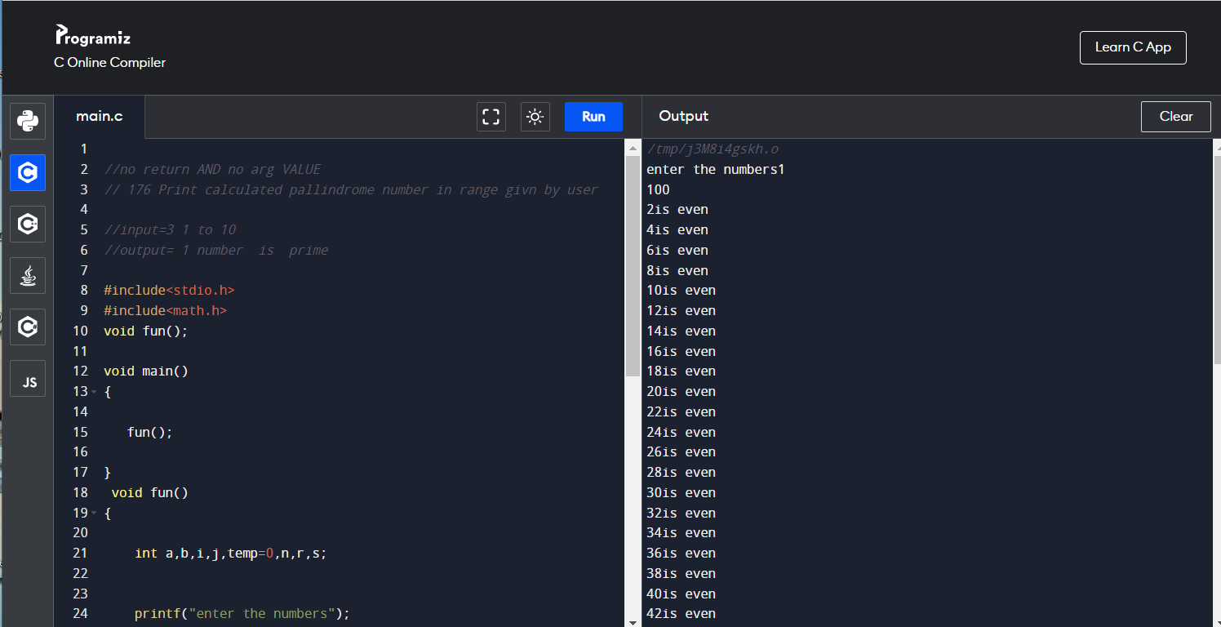

P24 odd no in range

181

//no return AND no arg VALUE

// 181Print calculated odd number in range givn by user

//input=3 1 to 10

//output=

#include<stdio.h>

#include<math.h>

void fun();

void main()

{

fun();

}

void fun()

{

int a,b,i,j,temp=0,n,r,s;

printf("enter the numbers");

scanf("%d%d",&a,&b);

for(j=a;j<=b;j++)

{

i=j;

if(i%2 != 0)

{

printf("%dis odd\n", i);

}

}

/* CHECKING IF THE NUMBER ENTERED AND THE REVERSE NUMBER IS EQUAL OR NOT */

}

182

// s of number

//175 no return AND with arg VALUE

//no return AND no arg VALUE

// 181Print calculated odd number in range givn by user

//input=3 1 to 10

//output=

#include<stdio.h>

#include<math.h>

void fun(int,int);

void main()

{

int a,b;

printf("enter the numbers");

scanf("%d%d",&a,&b);

fun(a,b);

}

void fun(int x1,int x2)

{

int a=x1,b=x2,i,j,temp=0,fact;

int n,r,s;

for(j=a;j<=b;j++)

{

i=j;

if(i%2 != 0)

{

printf("%dis odd\n", i);

}

}

}

